LANDING PAGE
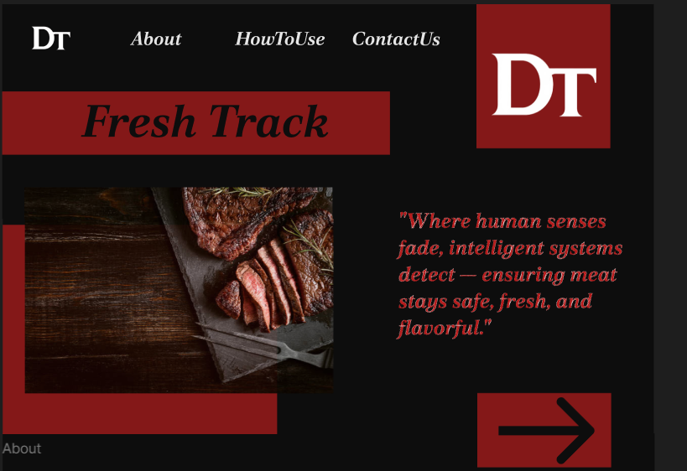

Font style : Poltawski Nowy

Color Scheme : B71C1C (Opacity = 70%) (deep red)
0D0D0D (black)
FFFFFF (white)

"Where human senses fade, intelligent systems detect — ensuring meat stays safe, fresh, and flavorful."

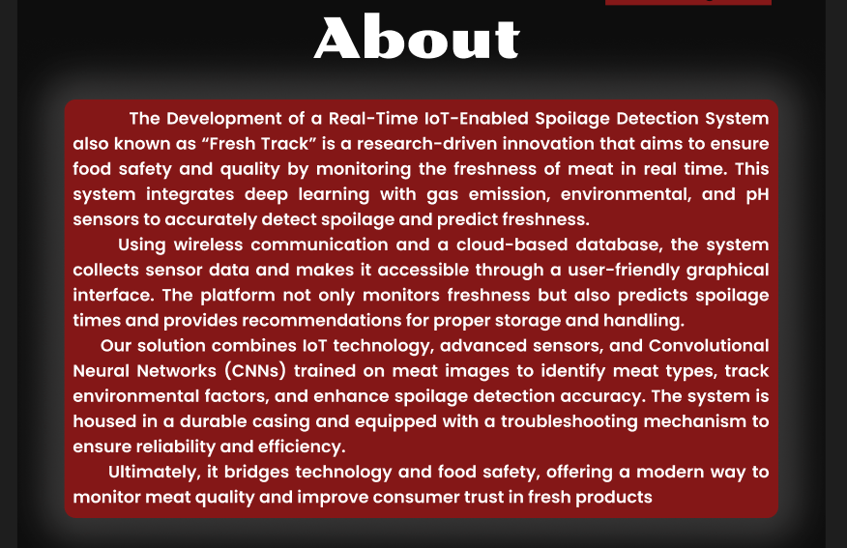
ABOUT PAGE

The Development of a Real-Time IoT-Enabled Spoilage Detection System also known as “Fresh Track” is a research-driven innovation that aims to ensure food safety and quality by monitoring the freshness of meat in real time. This system integrates deep learning with gas emission, environmental, and pH sensors to accurately detect spoilage and predict freshness.
Using wireless communication and a cloud-based database, the system collects sensor data and makes it accessible through a user-friendly graphical interface. The platform not only monitors freshness but also predicts spoilage times and provides recommendations for proper storage and handling.
Our solution combines IoT technology, advanced sensors, and Convolutional Neural Networks (CNNs) trained on meat images to identify meat types, track environmental factors, and enhance spoilage detection accuracy. The system is housed in a durable casing and equipped with a troubleshooting mechanism to ensure reliability and efficiency.
Ultimately, it bridges technology and food safety, offering a modern way to monitor meat quality and improve consumer trust in fresh products

HOW TO USE PAGE
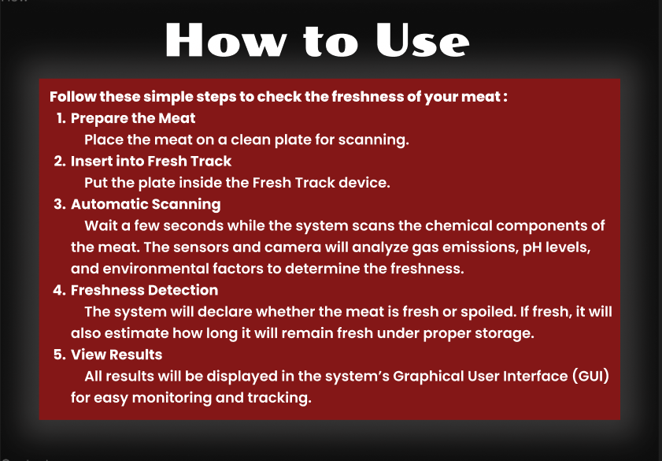
Follow these simple steps to check the freshness of your meat :
- Prepare the Meat Place the meat on a clean plate for scanning.
- Insert into Fresh Track Put the plate inside the Fresh Track device.
- Automatic Scanning Wait a few seconds while the system scans the chemical components of the meat. The sensors and camera will analyze gas emissions, pH levels, and environmental factors to determine the freshness.
- Freshness Detection The system will declare whether the meat is fresh or spoiled. If fresh, it will also estimate how long it will remain fresh under proper storage.
- View Results All results will be displayed in the system’s Graphical User Interface (GUI) for easy monitoring and tracking.

CONTACT US PAGE
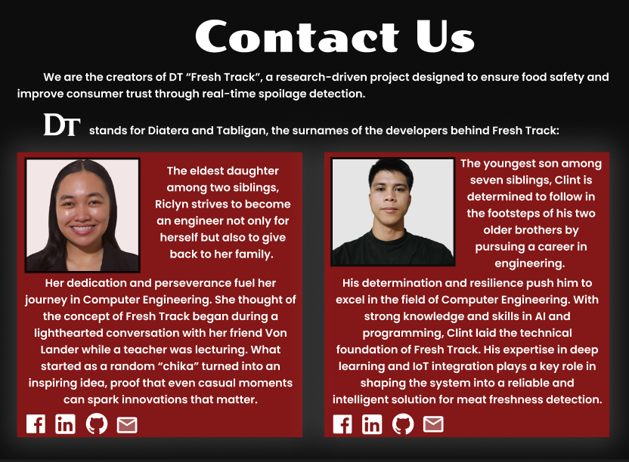
We are the creators of DT “Fresh Track”, a research-driven project designed to ensure food safety and improve consumer trust through real-time spoilage detection.

stands for Diatera and Tabligan, the surnames of the developers behind Fresh Track:

The eldest daughter among two siblings, Riclyn strives to become an engineer not only for herself but also to give back to her family.
Her dedication and perseverance fuel her journey in Computer Engineering. She thought of the concept of Fresh Track began during a lighthearted conversation with her friend Von Lander while a teacher was lecturing. What started as a random “chika” turned into an inspiring idea, proof that even casual moments can spark innovations that matter.
The youngest son among seven siblings, Clint is determined to follow in the footsteps of his two older brothers by pursuing a career in engineering.
His determination and resilience push him to excel in the field of Computer Engineering. With strong knowledge and skills in AI and programming, Clint laid the technical foundation of Fresh Track. His expertise in deep learning and IoT integration plays a key role in shaping the system into a reliable and intelligent solution for meat freshness detection.

MAIN PAGE
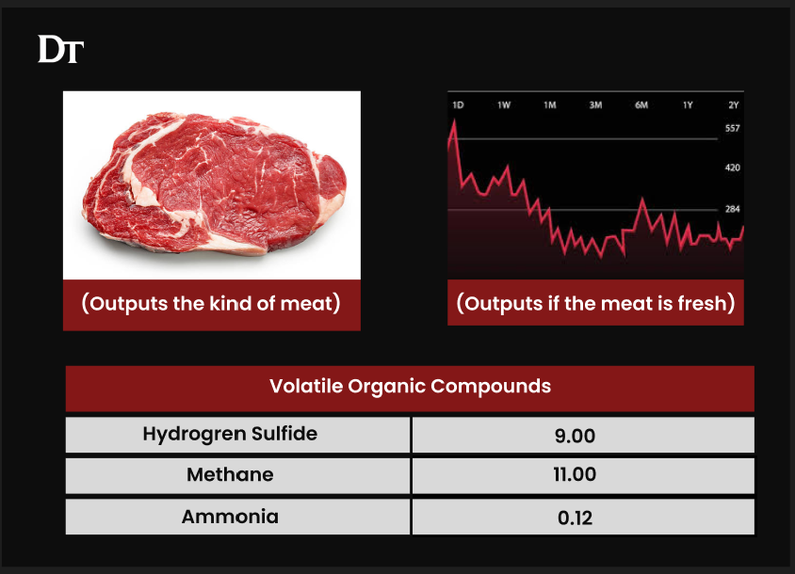

Figma Link : https://www.figma.com/design/o60hCCzYTmHQjdyDzz8e4S/THESIS?node-id=8-24&t=mJ9zlhGkC5aKQgSI-0

Make the icons functioning
RICLYN LINKS
FB : https://www.facebook.com/mariclyn.diatera
Linkedin : https://www.linkedin.com/in/ma-riclyn-diatera-439103296/
GitHub : https://github.com/mariadyatt
Email : https://mail.google.com/mail/?view=cm&fs=1&to=mariariclyndiatera@gmail.com

